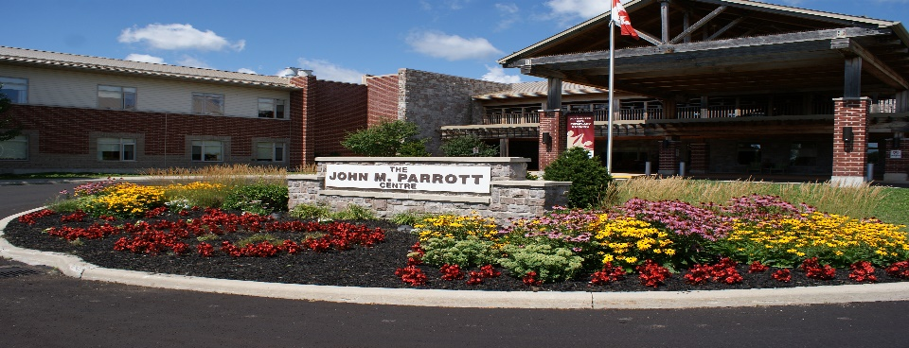

Family, caregivers and visitors coming into The John M Parrott Centre have an equal responsibility to do their part toward a safe visit for everyone to help maintain a safe environment for all.
The Pledge
We, the Home, pledge to do our part to keep family caregivers, residents and staff safe by:
- Communicating the current family presence or visitation status and procedures of visitation status via our newsletter and will ensure hard copies are available for you at the Home.
- Teach caregivers the safest way to put on and take off safety equipment such as masks and other personal protective equipment, and provide this equipment as needed.
- Enable caregivers to practice physical distancing with staff and other residents

I, the caregiver, pledge to do my part to keep the person I support, the other residents and the staff safe by:
- Follow existing public health orders to protect myself and reduce the risk of contracting or spreading COVID-19
- Answering screening questions honestly and accurately
- Following all instructions by LTC staff and asking questions when I don’t understand or need clarification
- Staying away from the Home when I am feeling unwell in any way.


Signed: _______________________________________ Date: ___________________________________

