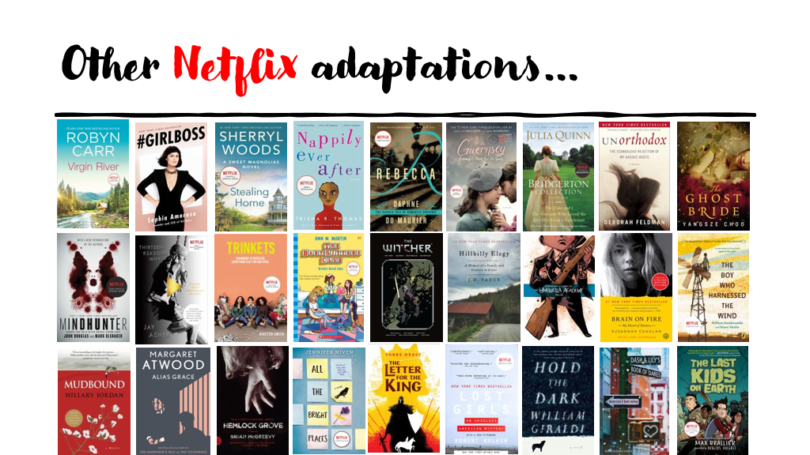

Where to keep up with this information:
https://www.perpetualpageturner.com/books-becoming-movies-upcoming/​https://reelgood.com/
https://www.netflix.com/browse/genre/1819174​
https://www.rottentomatoes.com/​
https://www.vulture.com/streaming/
https://www.whats-on-netflix.com/​
https://www.justwatch.com/us​
https://www.imdb.com/whats-on-tv/​
https://variety.com/what-to-watch-streaming-movies-shows-online/​
https://booklistqueen.com/books-to-movies-2021/

