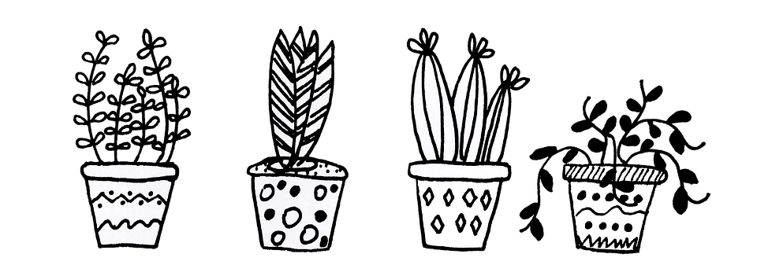

Garden Tour Plant Sale
Plant Donations

The Friends of the Rosendale Library are hosting our 2023 Garden Tour on June 10th. As part of this exciting day celebrating all of our local gardens and gardeners, we added a plant sale. Plants will be priced $1-$5.

We are seeking plant donations from our generous supporters. As you are opening your gardens this spring, if there are plants that you are dividing, thinning out or removing, please consider donating them to our plant sale.

Local plants of all kinds are welcome.
- Annuals
- Perennials
- Flowers
- Vegetables
- Fruit
- Shrubs

Plants can be dropped off outside the library, next to the shed beginning June 1st. Please exercise caution to not include garden pests along with your plants. If you need pots to transport them or have any questions, contact us at info@friendsofrl.org.

